**Course Name (CMPS-378)**

**Fall 2014**

**T 6:50 – 10 pm**

**Project # 5:**

**Title: Two Dimensional Arrays**

**Due Date: 11-04-14**

**GROUP #: 6**

**Grade:**

**e-mail:** [**jeremy.driesler@laverne.edu**](mailto:jeremy.driesler@laverne.edu) **Submitted by Jeremy Driesler**

**major: Computer Science/ Engineering concentration: Software**

|  |  |  |  |  |  |  |  |
| --- | --- | --- | --- | --- | --- | --- | --- |
| **Y**  **I**    **N** | **Description - 10%**  **= Incomplete**  **= No** | **Y**  **I**    **N** | **Design – 15%**  **UML and flowchart; pseudocode - if asked** | **Y**  **I**    **N** | **Code – 50%**  highlight and comments piece of the code which you had to **add** or **modify (worth 10 %)** | **Y**  **I**    **N** | **Test – 25%**  **Test plan (4 test cases – include boundary testing) with screenshot results** |

**Submitted to**

**Prof. Jozef Goetz**

**University of LA Verne, La Verne**

**Project Evaluation**

1. Create an application where the user puts in an array and the program adds the rows and columns of the Array.

**1a. Input**

The user will input the number of rows(rows) and the number of columns(columns). The user will then enter the values into the array.

**1b. Processing**

The program uses the TwoDimArrayTableTest class to run the program and get the array info from the user. It then calls three arrays from the TwoDimArrayTable class.

1. printArrayRows: prints the rows and the sum of the rows on the console
2. printColumnTotal: prints the sum of the columns on the console
3. calculates the total of all elements of the array and returns the value.

**1c. Output**

We print the array and all sums onto the screen

1. **Design (15%): UML**

**Class name: TwoDimArrayTableTest**

**rows : int = 0**

**columns : int = 0**

**array: int[,]**

**list of methods:**

**+ Main()**

**Class name: TwoDimArrayTable**

**rowTotal : int = 0**

**columnTotal: int = 0**

**arrayTotal: int =0**

**list of methods:**

**+ <constructor> GradeBook ( name : string)**

**+printArrayRows(array:int[,], r:uint, c:uint)**

**+printColumnTotal(array:int[,], r:uint, c:uint)**

**+ arrayTotal( array: int[,]) : int**

1. **Sample Inputs and Results (25%)**

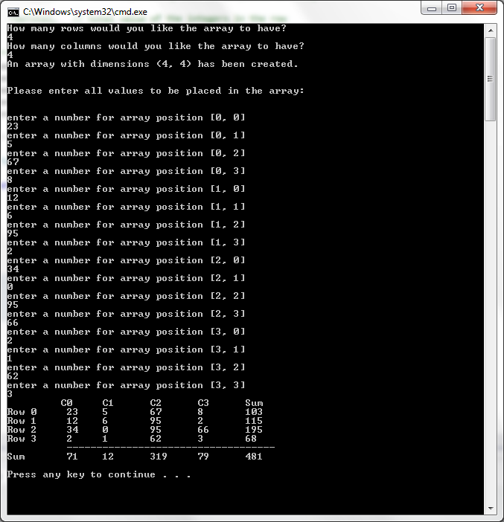

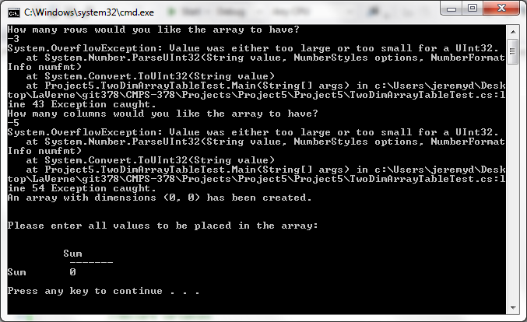

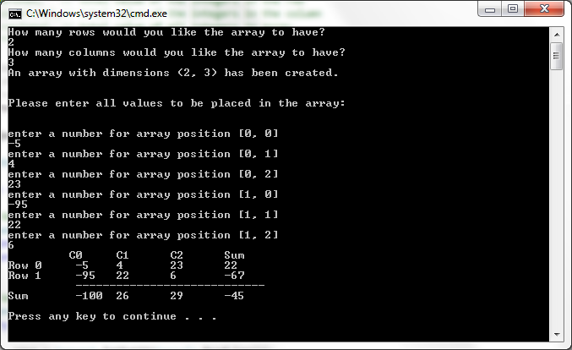

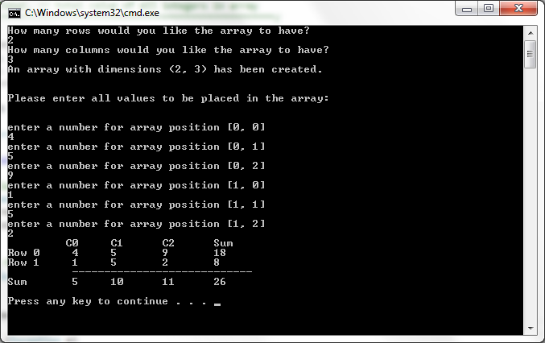

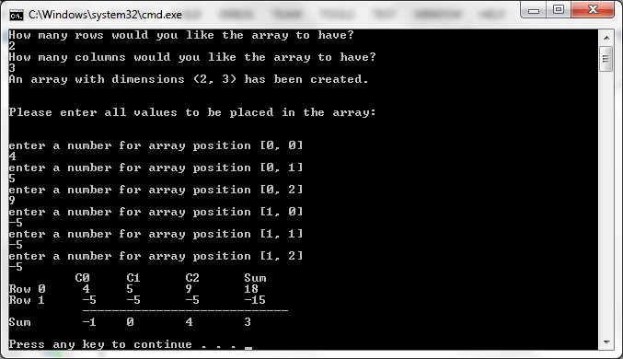

1. **Source Code** (**50%**)
2. /**********************place in your source code as first few lines**************************
3. * Name: Jeremy Driesler
4. * Class: CPMS 378,
5. * Assignment #: 5, Two Dimension Array
6. * Date Due: 11-04-14
7. * Problem Description
8. * Working with 2 dimensional arrays for the first time
9. * User inputs how many rows and columns to use for the array
10. * The users than inputs the desired values for the array they just created
11. * The program then prints out a table of the array with the total sum and sum of each row and column
12. * Type Variable Description
13. *Input:
14. int rows, // number of rows in array
15. columns, // number of columns in array
16. array[,], // value inputted by user to be placed in array
17. *Output:
18. int rowTotal, // total value of the integers in the row
19. columnTotal,// total value of the integers in the column
20. arrayTotal, // total calue of all integers in array
21. ******************************************************************/
22. using System;
23. using System.Collections.Generic;
24. using System.Linq;
25. using System.Text;
26. using System.Threading.Tasks;
27. namespace Project5
28. {
29. class TwoDimArrayTableTest
30. {
31. static void Main(string[] args)
32. {
33. //declare variables
34. TwoDimArrayTable twoTable = new TwoDimArrayTable();
35. uint rows = 0;
36. uint columns = 0;
38. //ask for user input
39. Console.WriteLine("How many rows would you like the array to have?");
40. try
41. {
42. rows = Convert.ToUInt32(Console.ReadLine());
43. }
44. catch (Exception e)
45. {
46. Console.WriteLine("{0} Exception caught.", e);
47. }
49. Console.WriteLine("How many columns would you like the array to have?");
51. try
52. {
53. columns = Convert.ToUInt32(Console.ReadLine());
54. }
55. catch (Exception e)
56. {
57. Console.WriteLine("{0} Exception caught.", e);
58. }
59. //create the array
60. int[,] array = new int[rows, columns];
61. Console.WriteLine("An array with dimensions ({0}, {1}) has been created.\n\n", rows, columns);
62. Console.WriteLine("Please enter all values to be placed in the array:\n\n");
63. // prompt user to input values for the array
64. for (int i = 0; i < rows; i++)
65. {
66. for (int j = 0; j < columns; j++)
67. {
68. Console.WriteLine("enter a number for array position [{0}, {1}]", i, j);
69. try
70. {
71. array[i, j] = Convert.ToInt32(Console.ReadLine());
72. }
73. catch(Exception e)
74. {
75. Console.WriteLine("{0} Exception caught.", e);
76. }
77. }
78. }
79. Console.Write("\t ");
80. //print the table header
81. for (int i = 0; i < columns; i++)
82. {
83. Console.Write("C{0}\t", i);
84. }
85. Console.Write("Sum\n");
86. //print the array and add the rows.
87. twoTable.printArrayRows(array, rows, columns);
88. //write the line under the array output
89. Console.Write("\t ");
90. for (int j = 0; j <= columns; j++)
91. {
92. Console.Write("-------");
93. }
94. Console.Write("\n");
95. //write the total of the array columns and total of all elements
96. Console.Write("Sum\t ");
97. twoTable.printColumnTotal(array, rows, columns);

100. //print total of all elements of the array
101. Console.Write("{0}\n\n", twoTable.arrayTotal(array));
102. }// end main method
103. }//end class TwoDimArrayTableTest
104. }//end namespace Project5
105. /**********************place in your source code as first few lines**************************
106. * Name: Jeremy Driesler
107. * Class: CPMS 378,
108. * Assignment #: 5, Two Dimension Array
109. * Date Due: 11-04-14
110. * Problem Description
111. * Working with 2 dimensional arrays for the first time
112. * User inputs how many rows and columns to use for the array
113. * The users than inputs the desired values for the array they just created
114. * The program then prints out a table of the array with the total sum and sum of each row and column
115. * Type Variable Description
116. *Input:
117. int rows, // number of rows in array
118. columns, // number of columns in array
119. array[,], // value inputted by user to be placed in array
120. *Output:
121. int rowTotal, // total value of the integers in the row
122. columnTotal,// total value of the integers in the column
123. arrayTotal, // total calue of all integers in array
124. ******************************************************************/
125. using System;
126. using System.Collections.Generic;
127. using System.Linq;
128. using System.Text;
129. using System.Threading.Tasks;
130. namespace Project5
131. {
132. class TwoDimArrayTable
133. {
134. //prints the rows and sums of the rows of an array
135. public void printArrayRows(int[,] array, uint r, uint c)
136. {
137. int rowTotal;
138. for (int i = 0; i < r; i++)
139. {
140. rowTotal = 0;
141. Console.Write("Row {0} ", i);
142. for (int j = 0; j < c; j++)
143. {
144. rowTotal += array[i, j];
145. Console.Write("{0}\t", array[i, j]);
146. }
147. Console.Write("{0}", rowTotal);
148. Console.WriteLine();
149. }
150. }//end printArrayRows
151. //prints the totals for the columns of an array
152. public void printColumnTotal(int[,] array, uint r, uint c)
153. {
154. int columnTotal;
155. for (int j = 0; j < c; j++)
156. {
157. columnTotal = 0;
158. for (int i = 0; i < r; i++)
159. {
160. columnTotal += array[i, j];
161. }
162. Console.Write("{0}\t", columnTotal);
163. }
164. }//end printColumnTotal
165. //returns the sum of all elements of an array
166. public int arrayTotal(int[,] array)
167. {
168. int arrayTotal = 0;
169. foreach (int digit in array)
170. {
171. arrayTotal += digit;
172. }
173. return arrayTotal;
174. }//end arrayTotal
175. }// class endTwoDimArrayTable
176. }// end namespace Project 5